Every element in the collection will be stored as Object.

Even if we provide Primitive type of data it will be converted to Object(Auto boxing) and then it will be stored.

LinkedList,ArrayDeque,Treeset has descending iterator using which we can traverse the elements in reverse order.

System.***out***.println("LinkedList,ArrayDeque,Treeset has descending iterator \nusing which we can traverse the elements in reverse order.");

Iterator itr=ll.descendingIterator();

while(itr.hasNext())

{

System.***out***.print(itr.next()+" ");

}

Vector:

Vector is legacy .

For iterating over the Vector elements, we will use Enumeration.

import java.util.Enumeration;

import java.util.Vector;

public class LaunchVector {

public static void main(String args[])

{

Vector vec=new Vector();

vec.add(100);

vec.add(200);

vec.add(300);

vec.add(400);

vec.add(500);

Enumeration en=vec.elements();

System.***out***.println("Vector Class Data");

while(en.hasMoreElements())

{

System.***out***.print(en.nextElement()+" ");

}

}

}

There might be old applications which would have written using Vector Class due to which it is not removed.

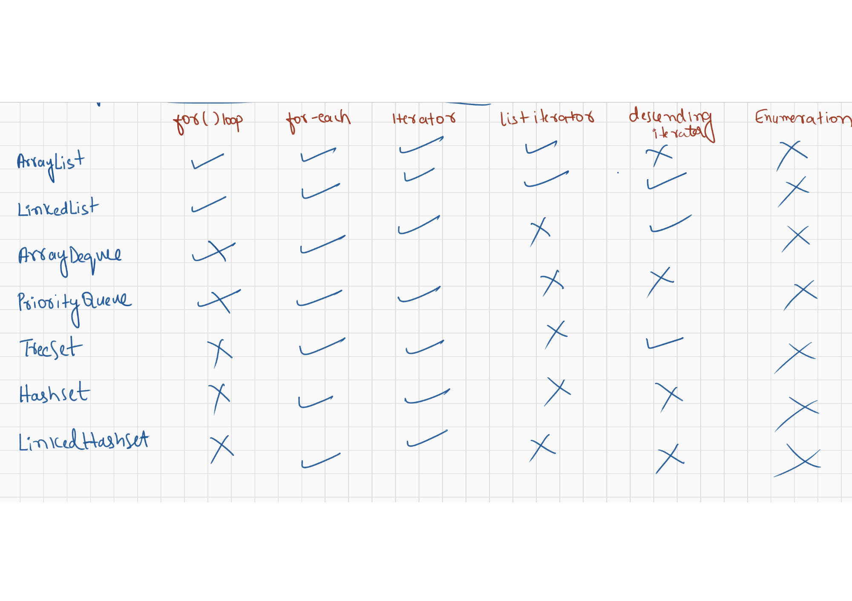

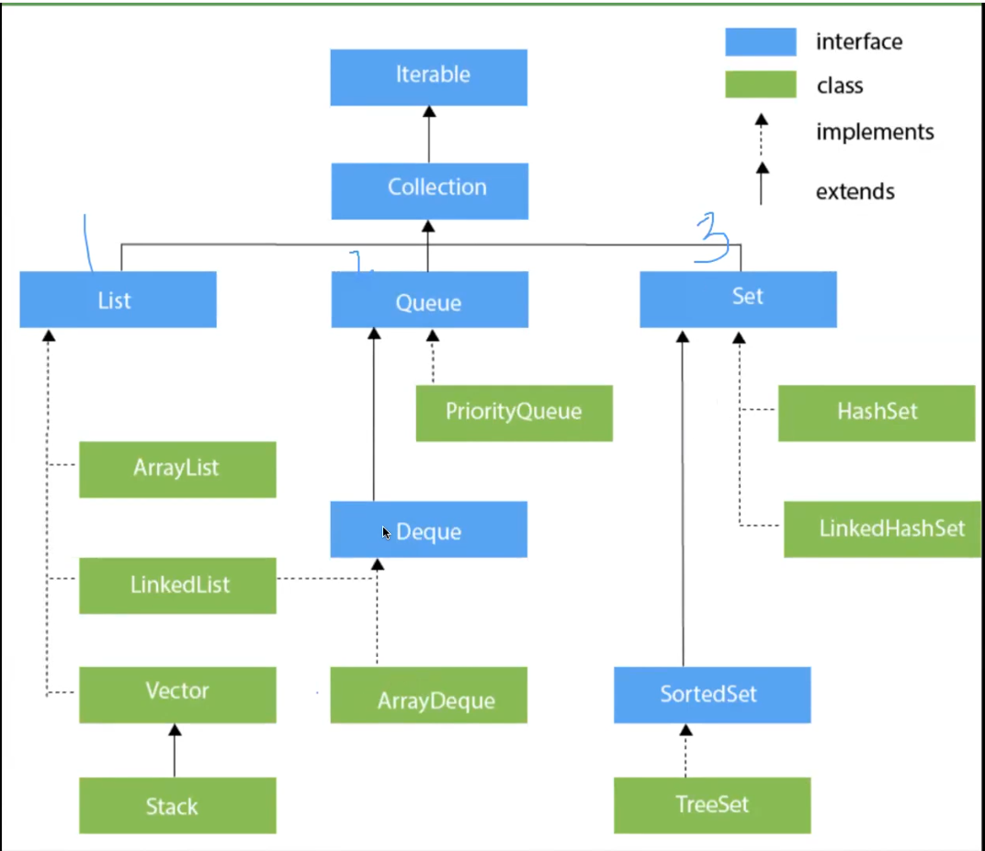

Concurrent Modification:

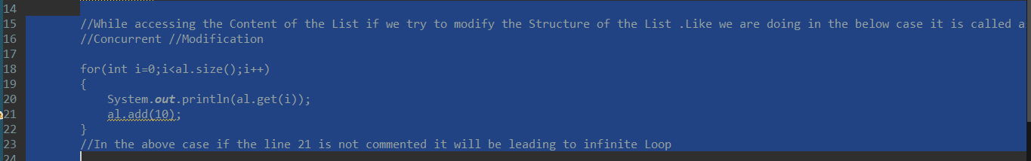

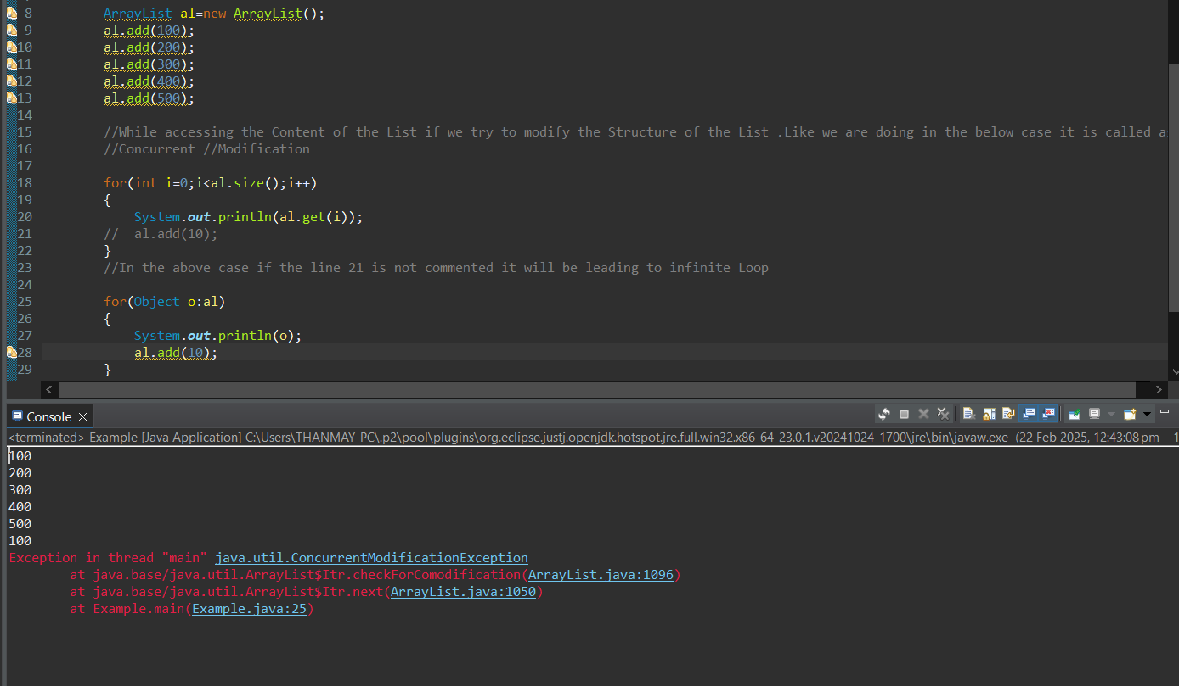

If we use for Each Loop, then also it will result java.util.ConcurrentModificationException

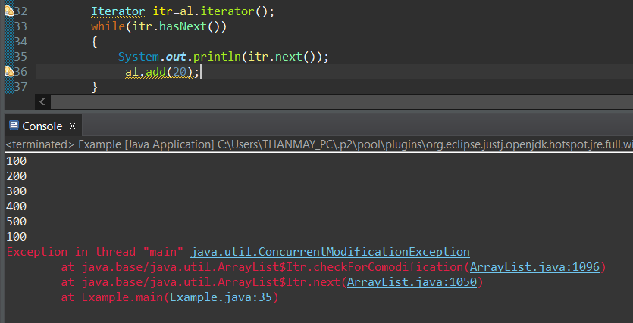

Iterator will also result in java.util.ConcurrentModificationException

Above is also called FailFast as soon it sees Concurrent Modification it will result in Exception.

**Fail Fast:**

When trying to do the Concurrent Modification it will result in Concurrent Modification issue

**Fail Safe:**

When trying to do the Concurrent Modification it will not allow to Concurrent Modification but will not raise any Exception as well

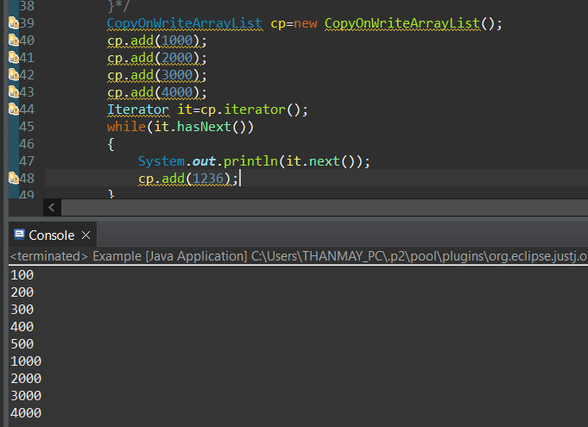

No Exception will be raised even if do concurrent Modification.

Concurrent Modification: Modifying the data when accessing it.

**ConcurrentModificationExceptionExample**

Collection: Set of interfaces and Classes

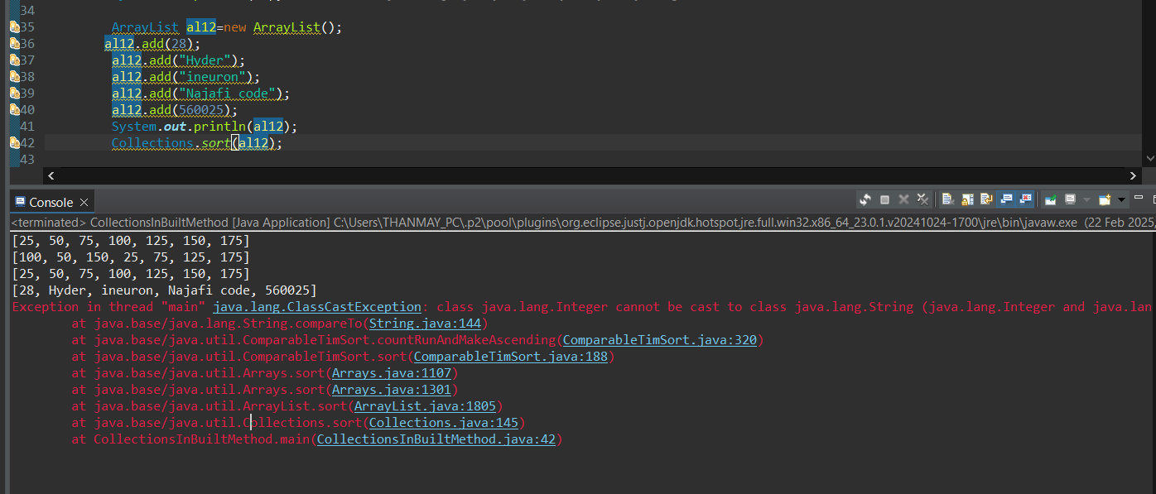

In the above Screen shot we could see that Array List is not limited to accept Particular datatype. Due to which we can add any type of data but when we trying to do sorting it is resulting in Exception.

We can solve the above by limiting ArrayList to accept specific datatype.

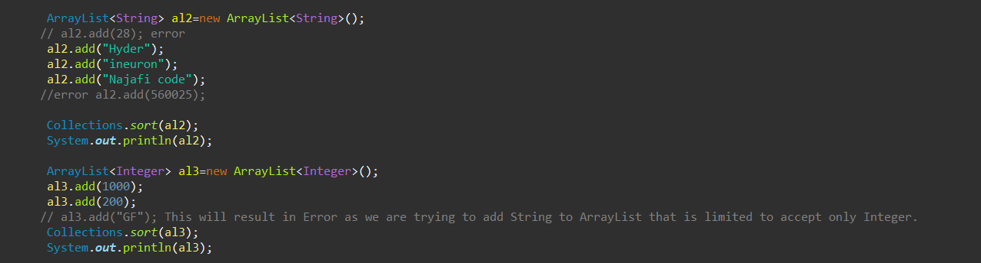

Refer 43-Collections-03

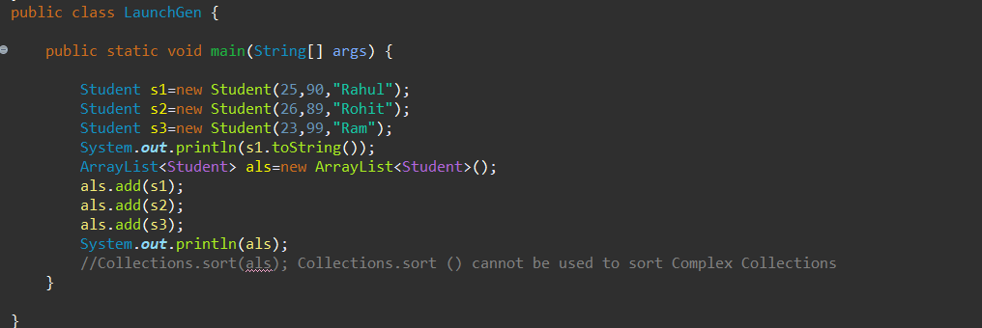

In the above case Student is also like Datatype using with we can store the data.